**NOTE: DO NOT TOUCH WHILE MOVING**

Ensure there is sufficient time for the antenna to reach the necessary direction for it to track accurately.

**Physical Parts included:**

Rambo Board - Einsy Rambo 1.2

Mount - Vixen Super Polaris Mount

Tripod - Explore Scientific Twilight Medium Duty Tripod

“Antenna” - currently a metal bar pointing to where the antenna should point

Stepper motors (2) - 42x38 mm Nema 17 Stepper Motor

3d printed stepper motor mounts (2)

Gears(2) - 60 Tooth 2GT timing pulleys - root circles bored to ~7 mm

Gears(2) - 20 Tooth 2GT pulleys - 5 mm root circles

Belts (2) - Length 200mm, Width 6mm

Antistatic wrist strap(s)

Jump Wires - 8 male to female

USB 2.0 A to B cable

**Physical Parts the user will have to provide:**

Allen Keys - 2 different sizes - for attaching stepper motors and tightening gears to shaft

Computer

DC power supply (or batteries) capable of supplying 12-24 V at 0.1-3.0 A.

**Software to install:**

Hamlib

Gpredict

Arduino IDE

**Steps:**

**Mechanical:**

Level the tripod.

Attach and secure the mount to the tripod.

Adjust the declination angle to its default state at 0,90. Adjust the right ascension angle to its default state at 0, 0. Make sure the lock for movement is tight. If it is not, the stepper motor will have no resistance to turn against.

Attach and secure the stepper motor mounts to the mount using the fitted rectangles and tighten them using the allen key.

Attach the stepper motors to the mounts using the bigger allen key and provided screws. Do not fully tighten the screws yet.

Attach the gears with the smaller root circle to the stepper motors. Tighten them with the smaller allen key to make them secure.

Attach the gears with larger root circles to the rotating shafts adjacent to the stepper motors. Tighten them with the smaller allen key to make them secure.

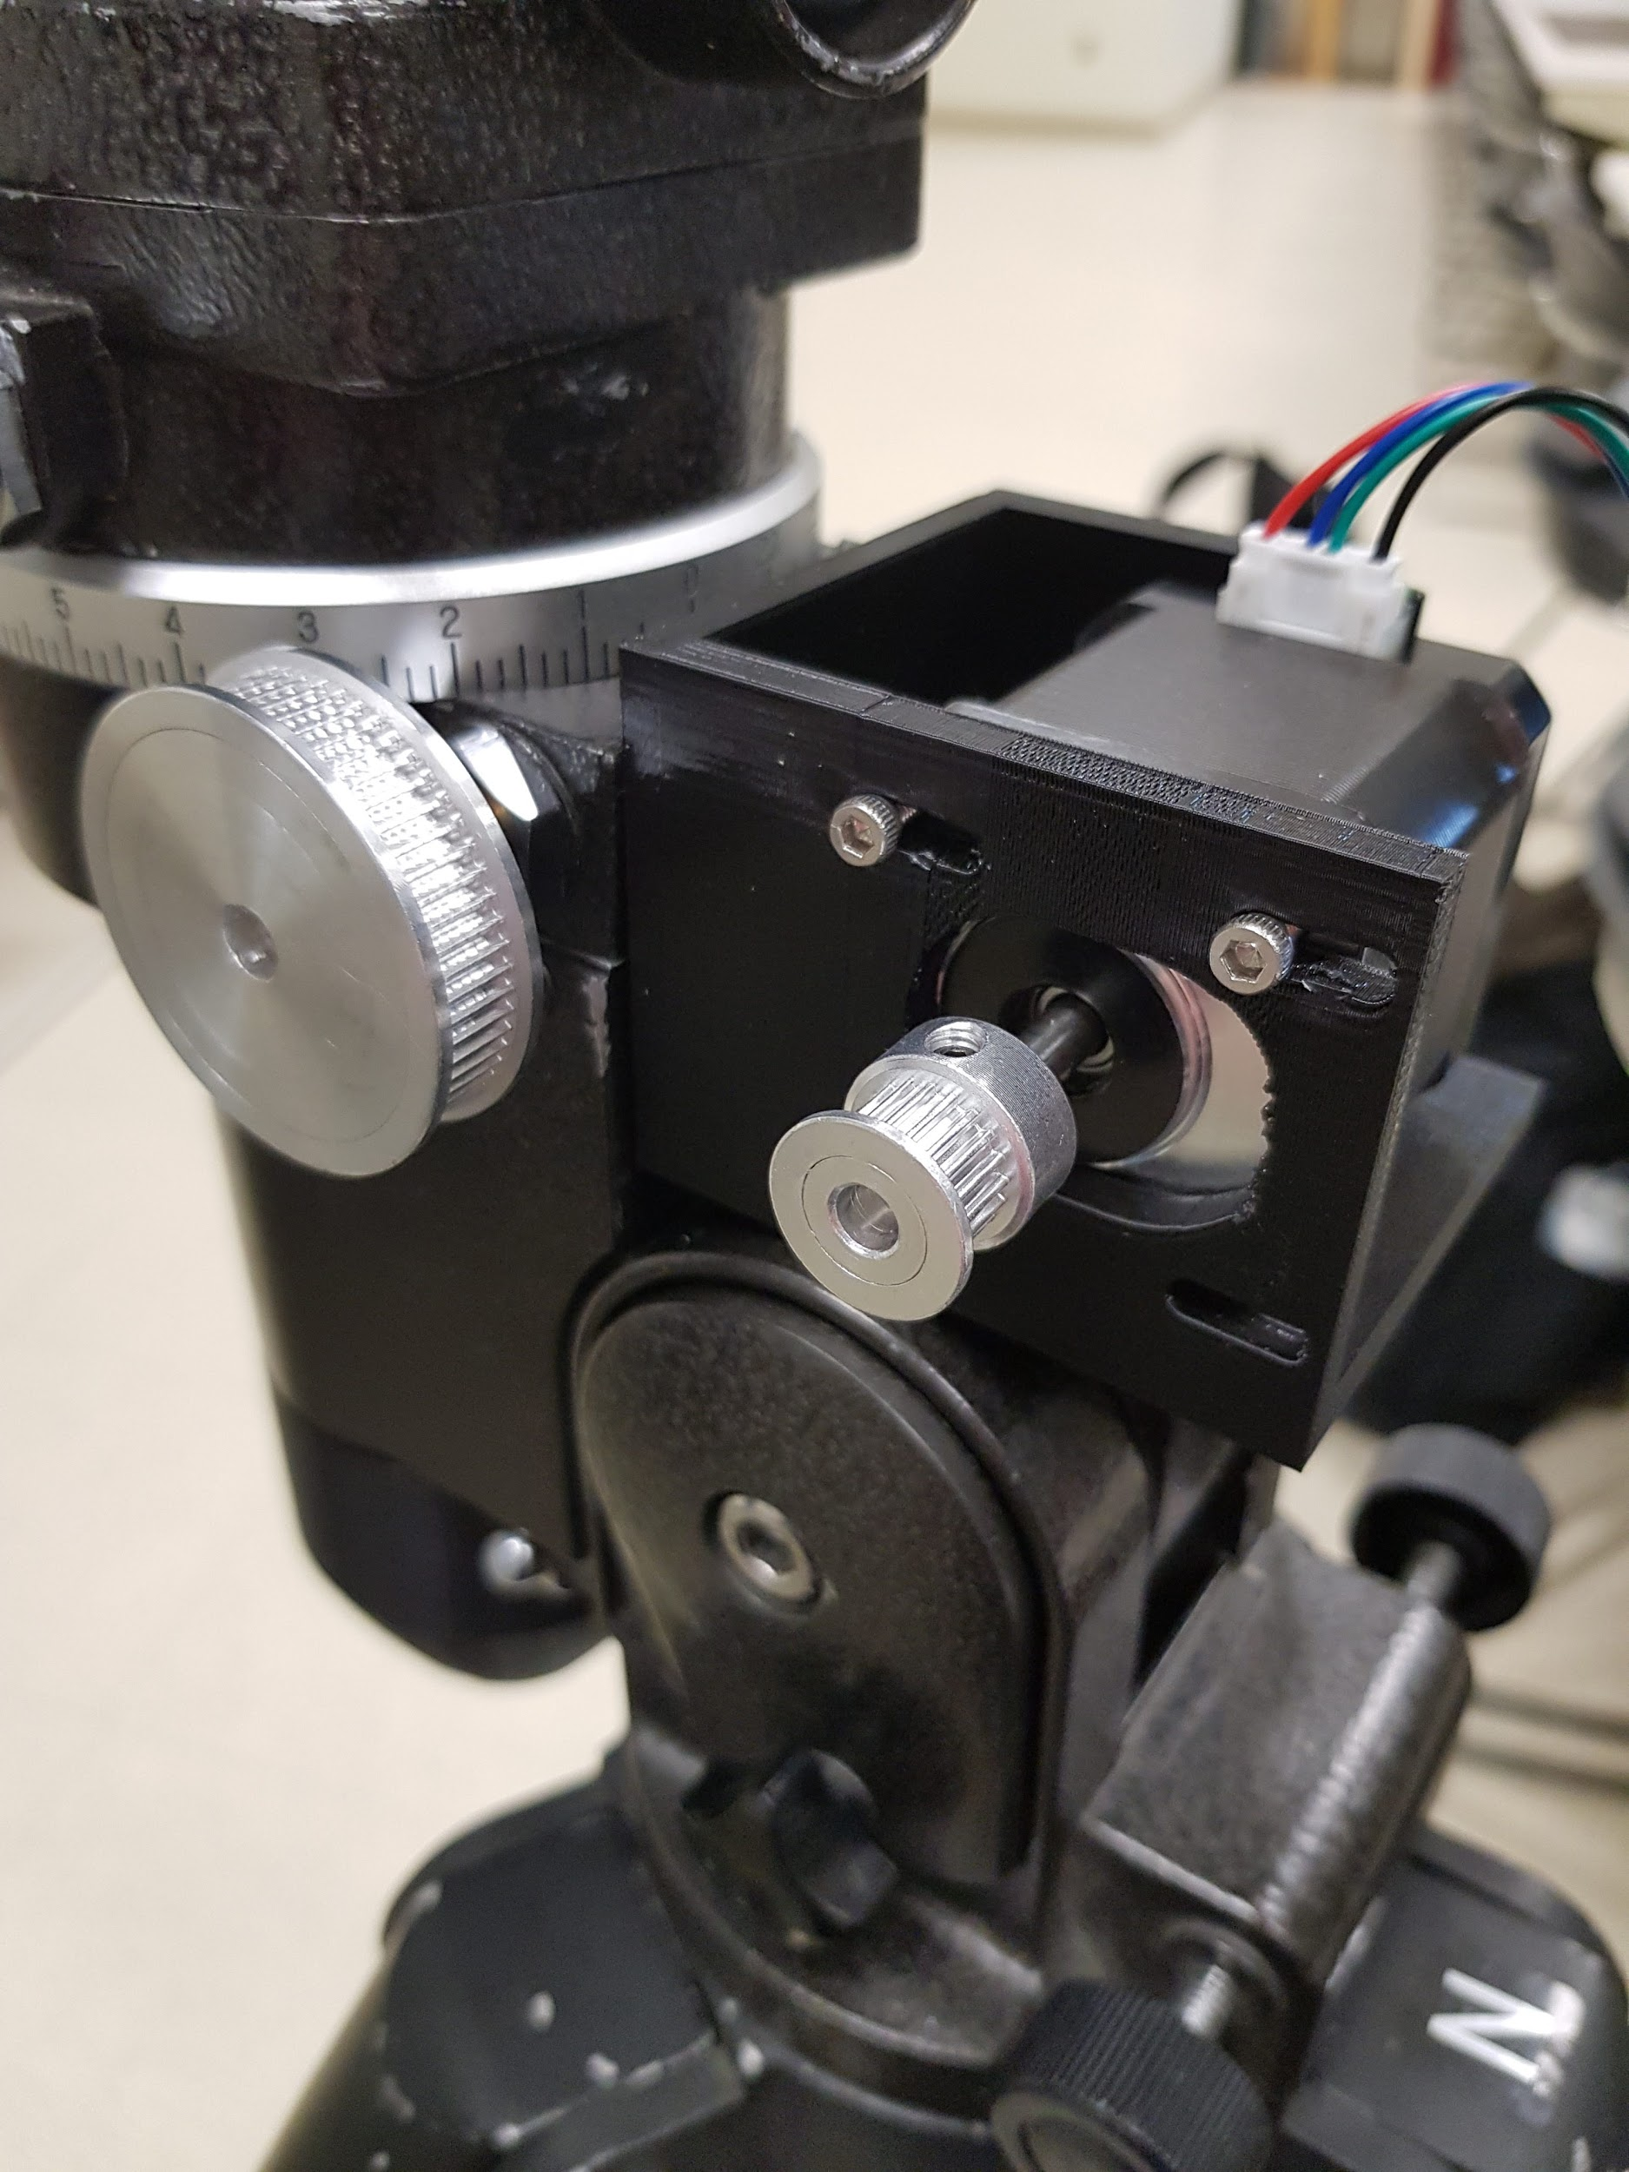

Connect the smaller gears to the larger gears using the belts.

Slide the stepper motors to the farthest place to make the band tight between the gears. Tighten the screws holding the stepper motor in order to secure it in place.

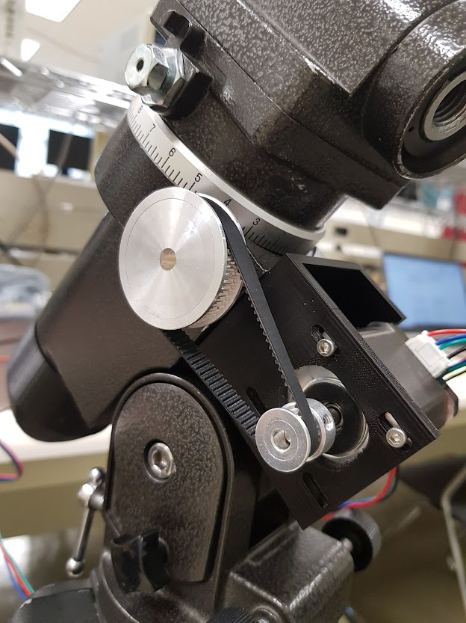

Attach the antenna. Ensure the antenna is pointed North.

**Electrical:**

Caution: Before touching the board, ensure that you are grounded. Use an antistatic wrist strap if possible. Failure to ground oneself before touching the board may damage the board and render the system inoperable.

Attach the power supply(off) to the Rambo board as per the labels on the website.

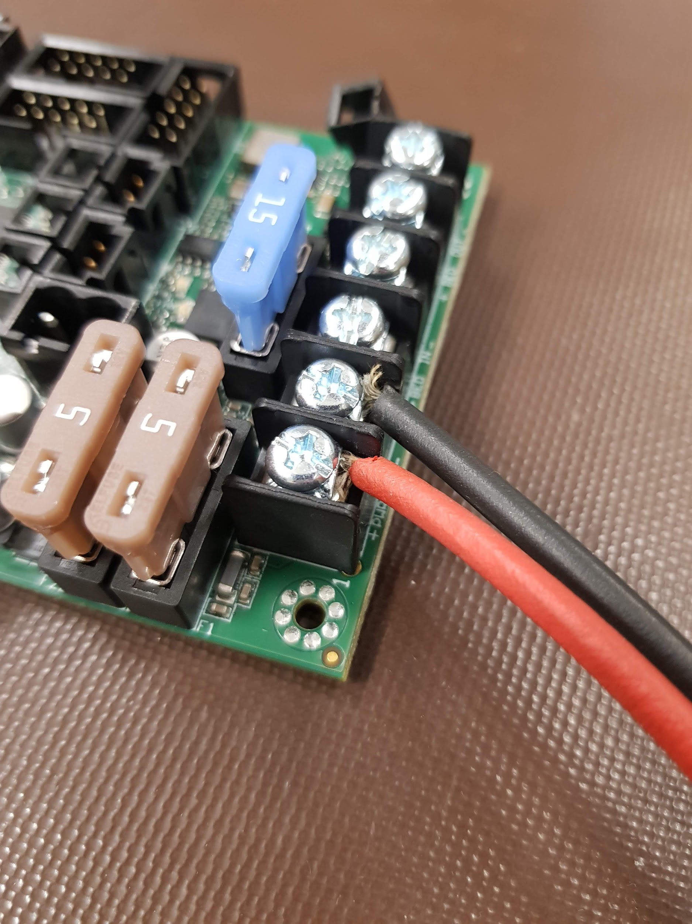

Attach the stepper motors to the x and y motors of the Rambo board.

x = R.A.

y = Dec.

If the wire connections are not secure, the motors will shake

If the gears are shaking- adjust the stepper motor’s connection to the Rambo board

Plug in the Rambo board to the computer using the USB cable.

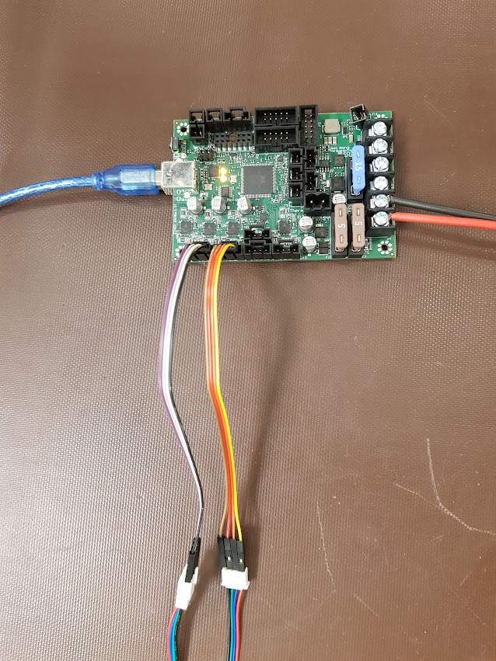

Turn on the power supply and set to >12 V

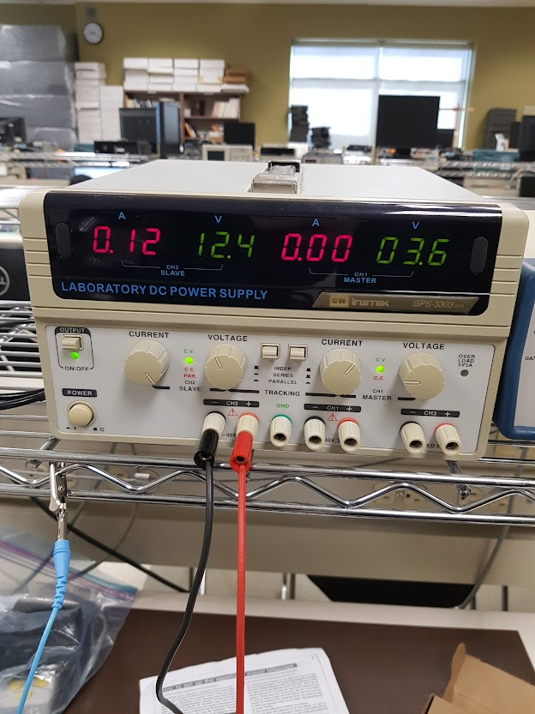

**Software:**

Caution: Before engaging the stepper motors, ensure that no one is touching the setup.

Go to the github link <https://github.com/JamMack123/ECE_492_Auto_Tracking_Antenna> and download the repo. Download the Arduino IDE version 2.0.4, and download Gpredict and Hamlib using the links in the readme. This has only been tested for a windows operating system.

Marlin.ino will need to be compiled and uploaded first in Marlin/Marlin-2.1.2/Marlin/, then the stepper_motor_controller.ino file in Gpredict_motor_firmware/Accelstepper_firmware/stepper_motor_controller/. Follow the readmes in the repo for the required libraries and arduino board required for compiling and uploading.

Once Gpredict and Hamlib are installed, and the firmware is uploaded to the board, edit the gpredict_bat.bat file with any text editor so that the com port is the same as the one connected to the board. Then put this batch file in C:\Program Files\hamlib-w64-4.5.5\bin and run it using the command prompt in administrator mode.

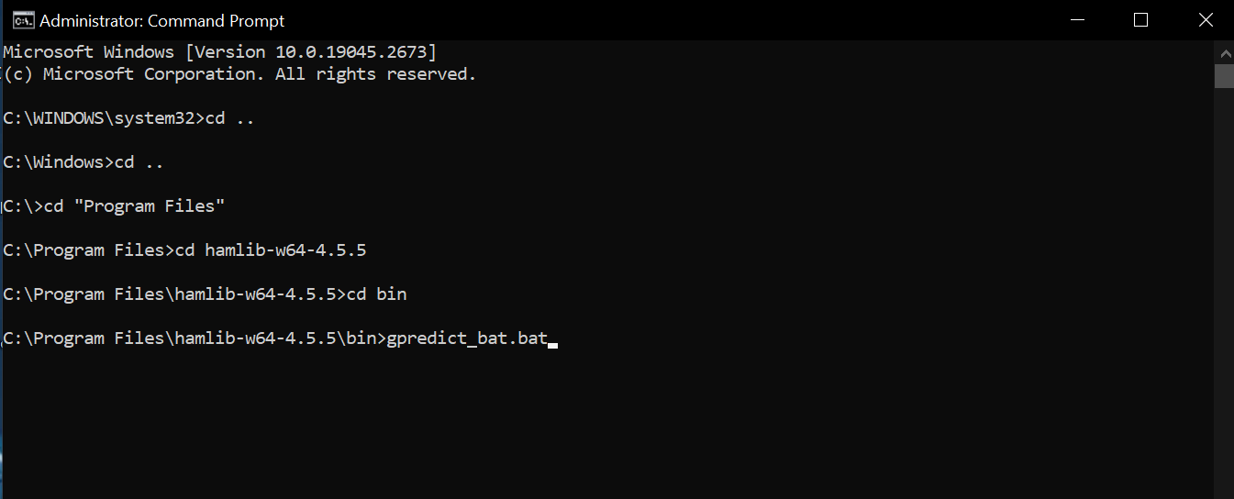

Next, launch Gpredict.exe and go to Edit > Preferences. Here you can add your ground station and set the TLE update to update in the background, then go to Interfaces > Rotators and add a new rotator. Give the rotator a name, the host should be localhost and the port should be 4533. Set the max azimuth to 240 degrees and the max elevation to 90 degrees.

Now you can click on the module options in Gpredict and go to the antenna control: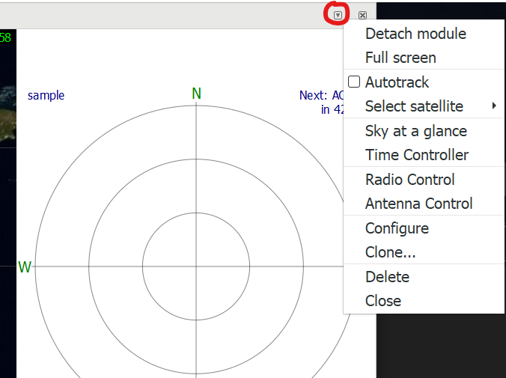

In the antenna control dialog, set the Azimuth and Elevation to 0 once the mount is correctly aligned, and click engage. You can then choose a target satellite and click track and the mount will start moving the antenna to the degrees shown on the screen.

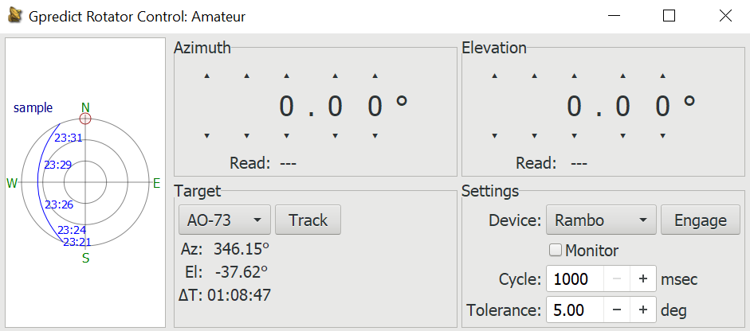

Manually adjusting the values in Gpredict causes it to break. - Only set it to zero and then let Gpredict do all the tracking using the track button.

**Emergency Stop:**

If for any reason the system must be shut off abruptly, press the reset button on the Rambo board. This will stop the motors and reset the memory on the board. Following an emergency reset, the user will need to reupload the driver code and firmware. This process can take between 5 and 10 minutes.

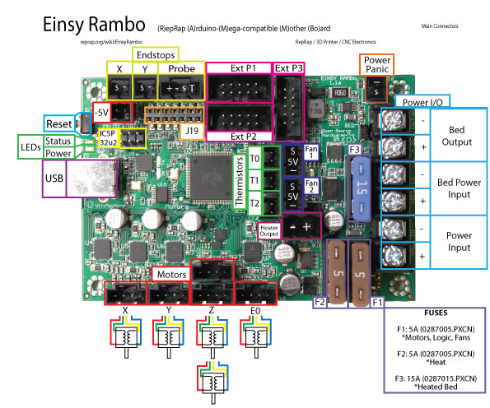

From: <https://reprap.org/wiki/File:EinsyRambo1.1a-connections.jpg>

